**DATABASE MANAGEMENT SYSTEMS LAB**

CSL-220

**LAB JOURNAL 6**



**NAME: MALIK ZOHAIB MUSTAFA**

**ENROLLMENT NO: 01-134192-030**

**CLASS: BS (CS)-4B**

**Department of Computer Sciences**

**BAHRIA UNIVERSITY, ISLAMABAD**

**LAB JOURNAL 6**

**True and False:**

Determine the validity of the following three statements. Circle either True or False.

1. Group functions work across many rows to produce one result per group.  
   **ANSWER:**

**True**

1. Group functions include nulls in calculations.  
   **ANSWER:**

**False**

1. The WHERE clause restricts rows prior to inclusion in a group calculation.  
   **ANSWER:**

**True**

**LAB TASK:**

**TASK NO 1:**

Write a query to list the number of jobs available in the employee’s table

**QUERY:**

SELECT

COUNT ( JOB )

FROM EMP;

**OUTPUT:**

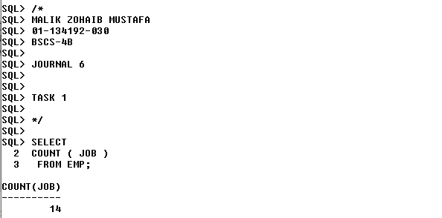

**TASK NO 2:**

Write a query to get the total salaries payable to employees

**QUERY:**

SELECT

SUM ( SAL ) "TOTAL SALARY"

FROM EMP;

**OUTPUT:**

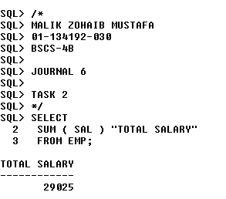

**TASK NO 3:**

Write a query to get the minimum salary from employee’s table

**QUERY:**

SELECT

MIN ( SAL ) "MINIMUM SALARY"

FROM EMP;

**OUTPUT:**

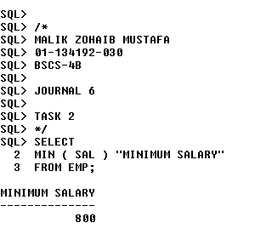

**TASK NO 4:**

Write a query to get the maximum salary of an employee

**QUERY:**

SELECT

MAX(SAL) "MAXIMUM SALARY"

FROM EMP;

**OUTPUT:**

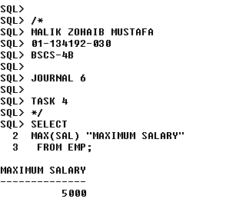

**TASK NO 5:**

Write a query to get the average salary and number of employees working the department 20

**QUERY:**

SELECT

AVG(SAL) "AVERAGE SALARY",

COUNT(*)"NUMBER OF EMPLOYEES"

FROM

EMP

WHERE

DEPTNO=20;

**OUTPUT:**

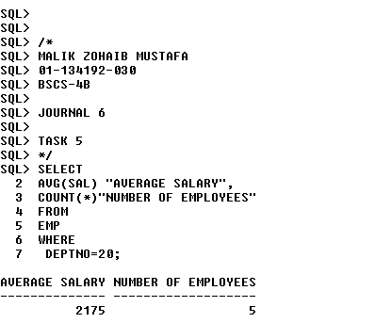

**TASK NO 6:**

Write a query to get the highest, lowest, sum, and average salary of all employees

**QUERY:**

SELECT ROUND (MAX (sal), 0) "Maximum", ROUND (MIN (sal), 0) "Minimum", ROUND (SUM (sal), 0) "Sum", ROUND (AVG (sal), 0) "Average" FROM emp;

**OUTPUT:**

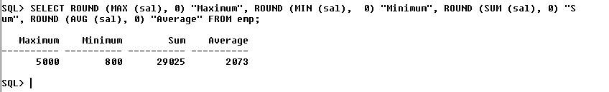

**TASK NO 7:**

Write a query to get the number of employees with the same job

**QUERY:**

SELECT JOB,

COUNT(*)

FROM EMP

GROUP BY JOB;

**OUTPUT:**

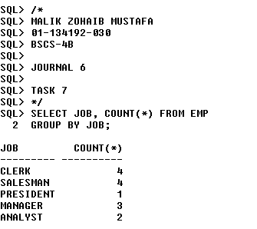

**TASK NO 8:**

Write a query to get the difference between the highest and lowest salaries

**QUERY:**

SELECT

MAX(SAL)-MIN(SAL) "DIFFERENCE"

FROM EMP;

**OUTPUT:**

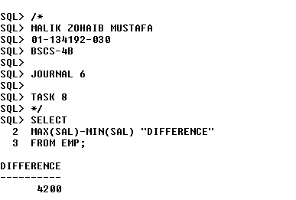

**TASK NO 9:**

Write a query to find the manager ID and the salary of the lowest-paid employee for that manager

**QUERY:**

SELECT MGR, MIN(SAL)

FROM EMP

WHERE MGR IS NOT NULL

GROUP BY MGR

ORDER BY MIN(SAL) DESC;

**OUTPUT:**

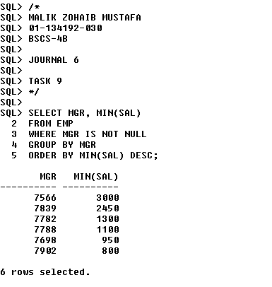

**TASK NO 10:**

Write a query to get the department ID and the total salary payable in each department

**QUERY:**

SELECT

DEPTNO,

SUM(SAL)

FROM EMP

GROUP BY DEPTNO;

**OUTPUT:**

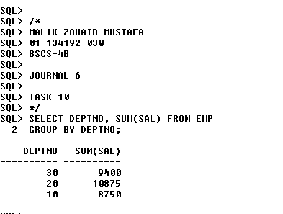

**TASK NO 11:**

Write a query to get the average salary for each job ID excluding programmer

**QUERY:**

SELECT JOB,

AVG(SAL)

FROM

EMP

WHERE

JOB < > 'PROGRAMMER'

GROUP BY JOB;

**OUTPUT:**

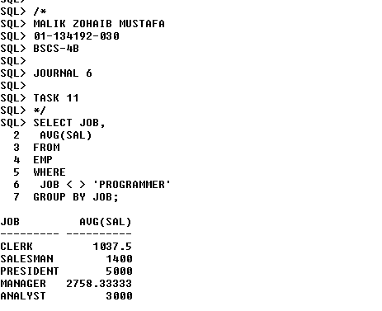

**TASK NO 12:**

Find the highest, lowest, sum, and average salary of all employees. Label the columns  
Maximum, Minimum, Sum, and Average, respectively. Round your results to the nearest  
whole number

**QUERY:**

SELECT ROUND(MAX(SAL),0) "MAXIMUM",

ROUND(MIN(SAL),0)"MINIMUM",

ROUND(SUM(SAL),0)"SUM",

ROUND(AVG(SAL),0)"AVERAGE"

FROM EMP;

**OUTPUT:**

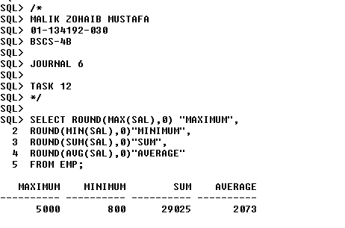

**TASK NO 13:**

Determine the number of managers without listing them. Label the column Number  
of Managers

**QUERY:**

SELECT

COUNT( DISTINCT MGR ) "NUMBER OF MANAGER"

FROM

EMP;

**OUTPUT:**

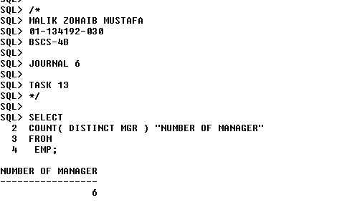

**TASK NO 14:**

Find the difference between the highest and lowest salaries. Label the column  
DIFFERENCE

**QUERY:**

SELECT

MAX(SAL) – MIN(SAL) “DIFFERENCE”

FROM

EMP;

**OUTPUT:**

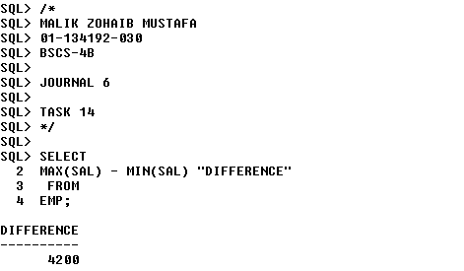

**TASK NO 15:**

Find the difference between the highest and lowest salaries. Label the column  
DIFFERENCE

**QUERY:**

SELECT

MAX(SAL) – MIN(SAL) “DIFFERENCE”

FROM

EMP;

**OUTPUT:**

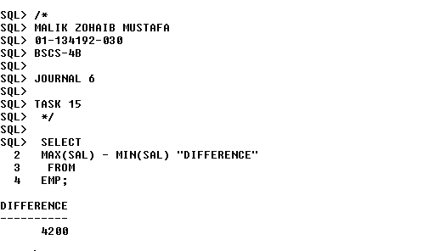

**END OF LAB JOURNAL**